FEB Interface Software User Guide

R. Kreswell Neely 05/10/2017

# Connecting the software to the FEB

1. Launch the TB_mu2e.exe application.
2. In the “FEB” tab, check that one of the buttons in the “CONNECTION” box shows the address 172.16.10.10. If so, click this button. If the connection is successful, the button will turn green. If not, it will turn red.
3. If the button does not display this address:
   1. Go to the “RUN” tab.
   2. Click the “CHANGE” button (approximately in the top center of the page). A new dialog box will open.
   3. Enter the address 172.16.10.10 into the “FEB1” box, click the “SET” button beside this box, then click “CLOSE.”
   4. Go back to the “FEB” tab and retry the connection.
4. If the button does display this address but the connection fails:
   1. Check the connection of all ethernet cables to the FEB, computer, and router.
   2. Check that the board appears to be powered on.

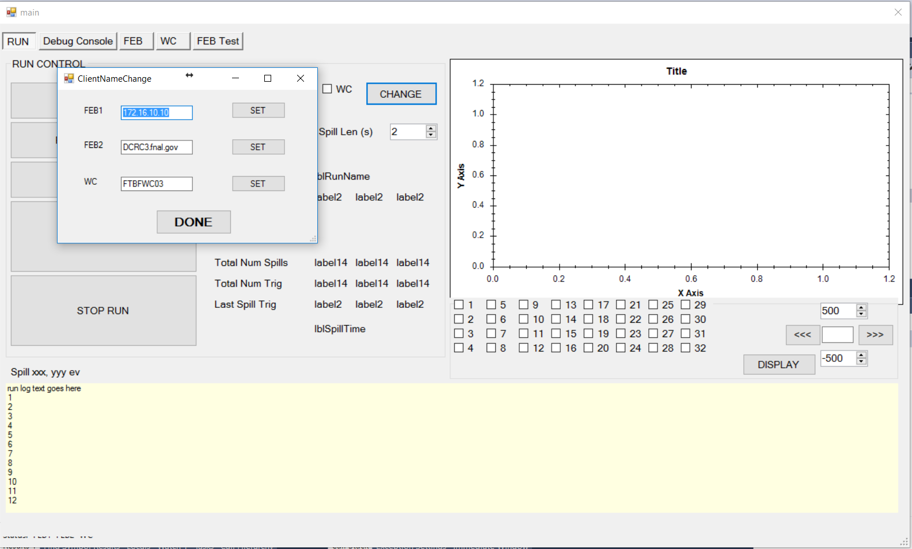

# Initial checks

If the board is connected and functioning properly:

1. The temperature and ID number for each CMB should appear in the center of the “FEB” tab (these values will be zero for any unconnected CMB channels).
2. The text boxes in the “REGISTERS” panel should display numbers, although most will likely be zero.

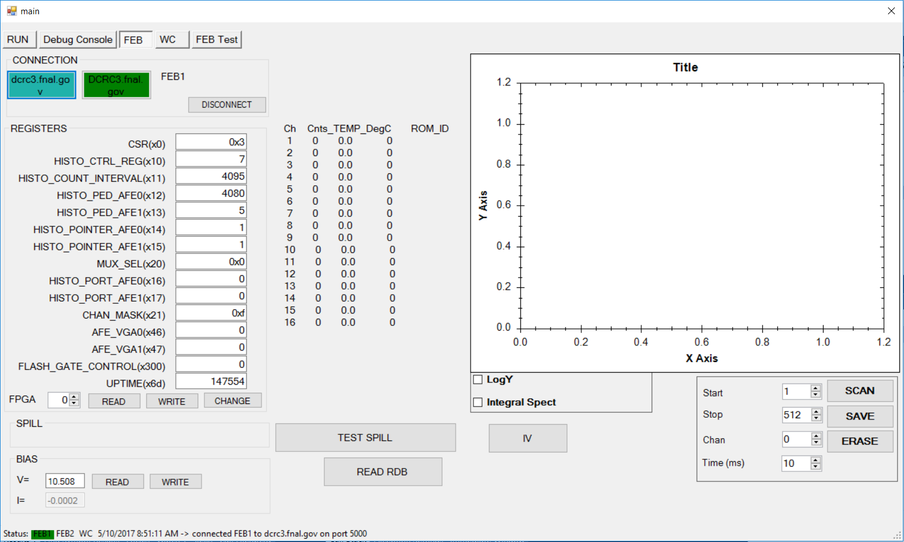

# DAC voltage test

1. Connect the HDMI test cable to the channel to be tested. It is recommended to begin with channel zero, J11 (leftmost when viewing FEB so that HDMI connections are at the bottom) and test sequentially.
2. Click on the button corresponding to the channel to be tested. The label on the button, J11 through J26, should match the label of the HDMI port on the FEB. The clicked button will turn red.
3. Click the “UPDATE” button in the “DAC Voltages” panel. The “READBACK” column should display numbers consistent with the “SETTING” column.
4. As a quick check, you can try setting one of the voltages to a nonzero value and make sure the readback approximately matches the setting. To do this, type the voltage setting into a box in the “SETTING” column and click “WRITE.” The voltage ranges for the DACs are:
   1. Bias: 0 -- 78V
   2. LED: 0 -- 14V
   3. TRIM: -4 -- +4V
5. Click the “SCAN” button. This will cycle through each of the six DACs (bias, LED, and four trims) setting each to a value and checking the readback voltage. This will be done for three voltages for each DAC. The button will now turn green.
6. Select a new channel. The selected channel button should turn red if untested, and previously tested channels should turn light green. Repeat the testing process
7. If the test cable appears to not be connected to the channel selected in the software, a warning message will appear. This is checked by setting the bias and trim voltages to nonzero values and checking that the readback is nonzero. If the warning appears, doublecheck the connection and channel selection. If you are certain you are connected to the correct port, this error may indicate a bad FEB.
8. Once all 16 channels are tested (all buttons are green or light green), click the “SAVE” button. This will write the results of the voltage scans to a text file in the data directory.

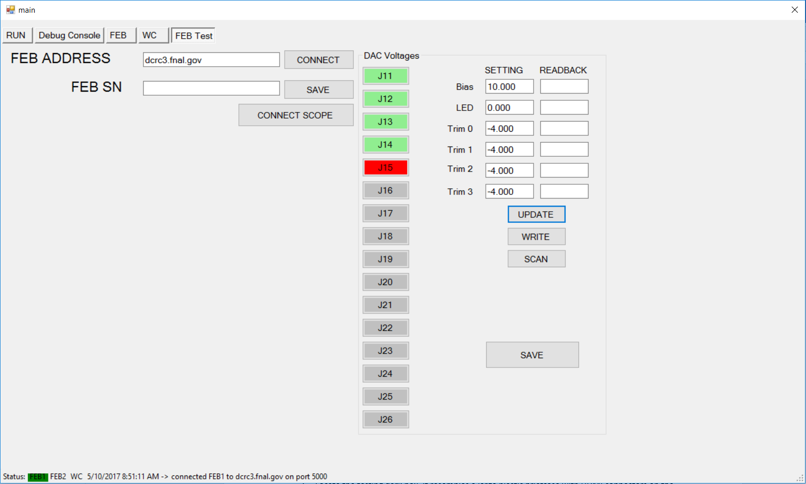

# Histogram test

1. Disconnect the voltage scan HDMI connector.
2. Locate the testing dark box. It resembles a large plastic briefcase with HDMI connectors on the side. [NOTE: as of 5/10/17, the dark box is still WIP.]
3. If doing the histogram test for the first time, check inside the dark box to confirm that all 16 CMBs (small PCBs, approximately 1”x4”, containing SiPMs) are in place and connected to the HDMI feedthroughs.
4. Connect the 16 HDMI channels on the FEB to the corresponding HDMI ports on the exterior of the dark box. [note: we should label the HDMI connectors on the dark box so we’re consistent about which CMBs are used each time.]
5. In the “FEB” tab, click the “SCAN” button on the lower right.
6. The button will turn blue while it’s scanning.
7. Once the scan is complete, click “SAVE.”
8. A file will be created titled with the FEB serial number and the date.